PART 1: DETAILED MEETING SCRIPT
ACES Kickoff Meeting - Complete Script
Duration: 60-75 minutes
Audience: Engineering team (2-4 people)

1. OPENING (5 mins)
"Good morning everyone. Thanks for joining.
Today marks the beginning of building our second product from scratch: ACES - the Autonomous Cognitive Engineering System.
Before we dive in, let me set the context:
We're not building just another tool or service. We're building an intelligent execution layer that sits between detection systems and action systems.
Think of it this way:
- Current systems detect problems (Snyk, Sonar, CertGuardian)
- ACES decides what to do and executes the solution
That's the core idea. Let me explain why this matters."

2. THE PROBLEM (10 mins)
"Right now, our engineering workflow looks like this:
Step 1: Developer pushes code
Step 2: Snyk scans for vulnerabilities
Step 3: Build fails ❌
Step 4: Engineer investigates
Step 5: Engineer manually fixes
Step 6: Re-run pipeline
The problem? Everything is reactive and manual.
Specific gaps:
- No intelligence - Binary pass/fail, no context
- No automation - Humans do all the work
- No learning - Same mistakes repeated
- No governance - Decisions aren't tracked or auditable
Real example from CertGuardian:
- Certificate renewed ✅
- App still uses old cert ❌
- Alert generated ✅
- ...then nothing happens automatically
That's where ACES comes in."

3. WHAT ACES IS (10 mins)
"ACES transforms this workflow:
Old way: Detect → Fail → Human fixes
New way: Detect → Decide → Act → Verify
ACES is a governed agentic execution platform with 4 core capabilities:
1. Signal Ingestion
- Consumes events from Snyk, Sonar, CertGuardian, CI/CD
- Normalizes different formats
- Assigns correlation IDs
2. Decision Engine
- Evaluates context (environment, criticality, risk)
- Applies policies and rules
- Decides: Block, Allow, Remediate, or Escalate
3. Execution Layer
- Triggers actions via MCP/plugins
- Can call APIs, restart services, create tickets
- All actions are auditable
4. Verification Loop
- Confirms the action worked
- Closes the loop
- Learns for next time
Simple analogy:
- Current systems = Fire alarm (just rings)
- ACES = Smart firefighting system (detects, decides, suppresses)"

4. ARCHITECTURE OVERVIEW (15 mins)
[Show the architecture diagram here]
"Let me walk through the architecture:
Input Sources (Left side):
- Snyk, SonarQube, CertGuardian, CI/CD pipelines
- These generate signals
Signal Ingestion Layer:
- API Gateway receives all events
- Validates and normalizes
Context Engine:
- Enriches signals with:
  - Environment (dev/prod)
  - Criticality (high/medium/low)
  - Service ownership
Decision Engine (The Brain):
- Applies rules and policies
- AI/rules hybrid (Phase 1 = rules only)
- Outputs: Block, Remediate, Notify, or Ticket
Outputs/Actions (Right side):
- Jira tickets
- Alerts/notifications
- CI/CD control (pause/resume)
- Config management APIs
Upstream Integration:
- ARIA (future) - provides high-level policies and decision intelligence
Downstream Integration:
- CertGuardian Neo - provides certificate/TLS data
Key point: ACES works standalone, but integrates beautifully with existing systems."

5. LIVE USE CASE WALKTHROUGH (10 mins)
"Let me show you a concrete scenario:
Scenario: Certificate runtime drift detection
Current flow:
- Cert renewed in DCM
- App still uses old cert
- CertGuardian detects mismatch
- Alert in dashboard
- Engineer investigates (hours later)
- Engineer restarts service manually
- Engineer verifies fix
ACES flow:
- CertGuardian sends signal → ACES
- ACES evaluates: Drift detected ✅
- Decision: Auto-remediate (restart service)
- Policy check: Approved for non-prod ✅
- Execution: Trigger team-owned agent
- Agent restarts service
- Verification: CertGuardian re-checks → Fixed ✅
- Audit log: Complete trail
Total time: 2 minutes vs 4 hours
That's the power of ACES."

6. PHASE 1 SCOPE (5 mins)
"We're not building everything at once.
Phase 1 MVP (4 weeks): ✅ Signal ingestion (REST APIs)
✅ Basic decision engine (rule-based)
✅ Mock execution (print statements)
✅ Simple verification
✅ Audit logging
NOT in Phase 1: ❌ Full AI/ML decisioning
❌ Multi-tenant support
❌ Complex UI
❌ All integrations
Success criteria:
- End-to-end flow works
- One use case fully automated (CertGuardian drift)
- Team can demo to leadership"

7. TEAM STRUCTURE & ROLES (5 mins)
"Here's how we'll divide the work:
Person 1 (You - Lead):
- Overall architecture
- Decision engine
- Orchestrator
- Integration strategy
Person 2:
- Ingestion service
- Evaluation logic
- Plugin/execution layer
Person 3 (if available):
- Policy engine
- Audit service
- Verification service
Person 4 (if available):
- UI/dashboard
- API contracts
- Testing
We'll work in weekly sprints with daily standups."

8. TECH STACK (3 mins)
"Technology decisions:
Backend:
- Java 21 + Spring Boot 3
- Maven
- PostgreSQL (Oracle 23ai if available)
Communication:
- REST APIs (Phase 1)
- Kafka (Phase 2+)
Observability:
- OpenTelemetry
- Dynatrace integration
Deployment:
- GAIA (private cloud)
- Container-based
Why this stack:
- Team expertise
- Enterprise standards
- Scalability"

9. WEEK 1 PLAN (2 mins)
"This week, we focus on:
Day 1-2: Project setup + common models
Day 3-4: Ingestion service + evaluation
Day 5: Decision engine (basic rules)
Deliverable:
- Working signal ingestion API
- Basic drift detection logic
- Team demo
I'll share detailed tasks after this meeting."

10. Q&A + NEXT STEPS (5 mins)
"Questions?
What I need from you:
- Confirm availability for 4-week sprint
- Identify any blockers
- Suggest simplifications
After this meeting:
- I'll share architecture diagrams
- API contracts
- Detailed task breakdown
- GitHub repo setup
Let's build something great."

📊 PART 2: VISUAL ARCHITECTURE DIAGRAMS
Here are Mermaid diagrams you can render instantly:
Diagram 1: ACES High-Level Architecture
mermaid
flowchart TB
subgraph Inputs["📥 Input Sources"]
Snyk["🛡️ Snyk"]
Sonar["📊 SonarQube"]
CertGuardian["🔐 CertGuardian"]
CICD["⚙️ CI/CD Pipeline"]
end

subgraph ACES["🧠 ACES Platform"]
direction TB

Ingestion["📡 Signal Ingestion Layer\nAPI Gateway + Normalization"]
Context["🎯 Context Engine\nEnvironment + Criticality + Service Context"]
Decision["🧠 Decision Engine\nRisk Analysis + Policy Decisions"]

subgraph Actions["🎬 Action Outcomes"]
Block["🚫 Block"]
Remediate["🔧 Remediate"]
Notify["📢 Notify"]
Ticket["🎫 Create Ticket"]
end
end

subgraph Outputs["📤 Outputs / Actions"]
Jira["🎯 Jira / Ticketing"]
Alerts["🔔 Alerts & Notifications"]
Control["⚡ CI/CD Control"]
APIs["🔌 Config Mgmt / APIs"]
end

subgraph Integrations["🔄 Integrations"]
Upstream["⬆️ ARIA\nDecision Intelligence\nHigh-Level Policies"]
Downstream["⬇️ CertGuardian Neo\nCert/TLS Data\nCertificate Risks"]
end

Inputs --> Ingestion
Ingestion --> Context
Context --> Decision
Decision --> Actions
Actions --> Outputs

Upstream -.-> Decision
Downstream -.-> Context

style ACES fill:#1e3a8a,stroke:#3b82f6,stroke-width:3px,color:#fff
style Decision fill:#3b82f6,stroke:#1e40af,stroke-width:2px,color:#fff
style Inputs fill:#065f46,stroke:#10b981,color:#fff
style Outputs fill:#92400e,stroke:#f59e0b,color:#fff

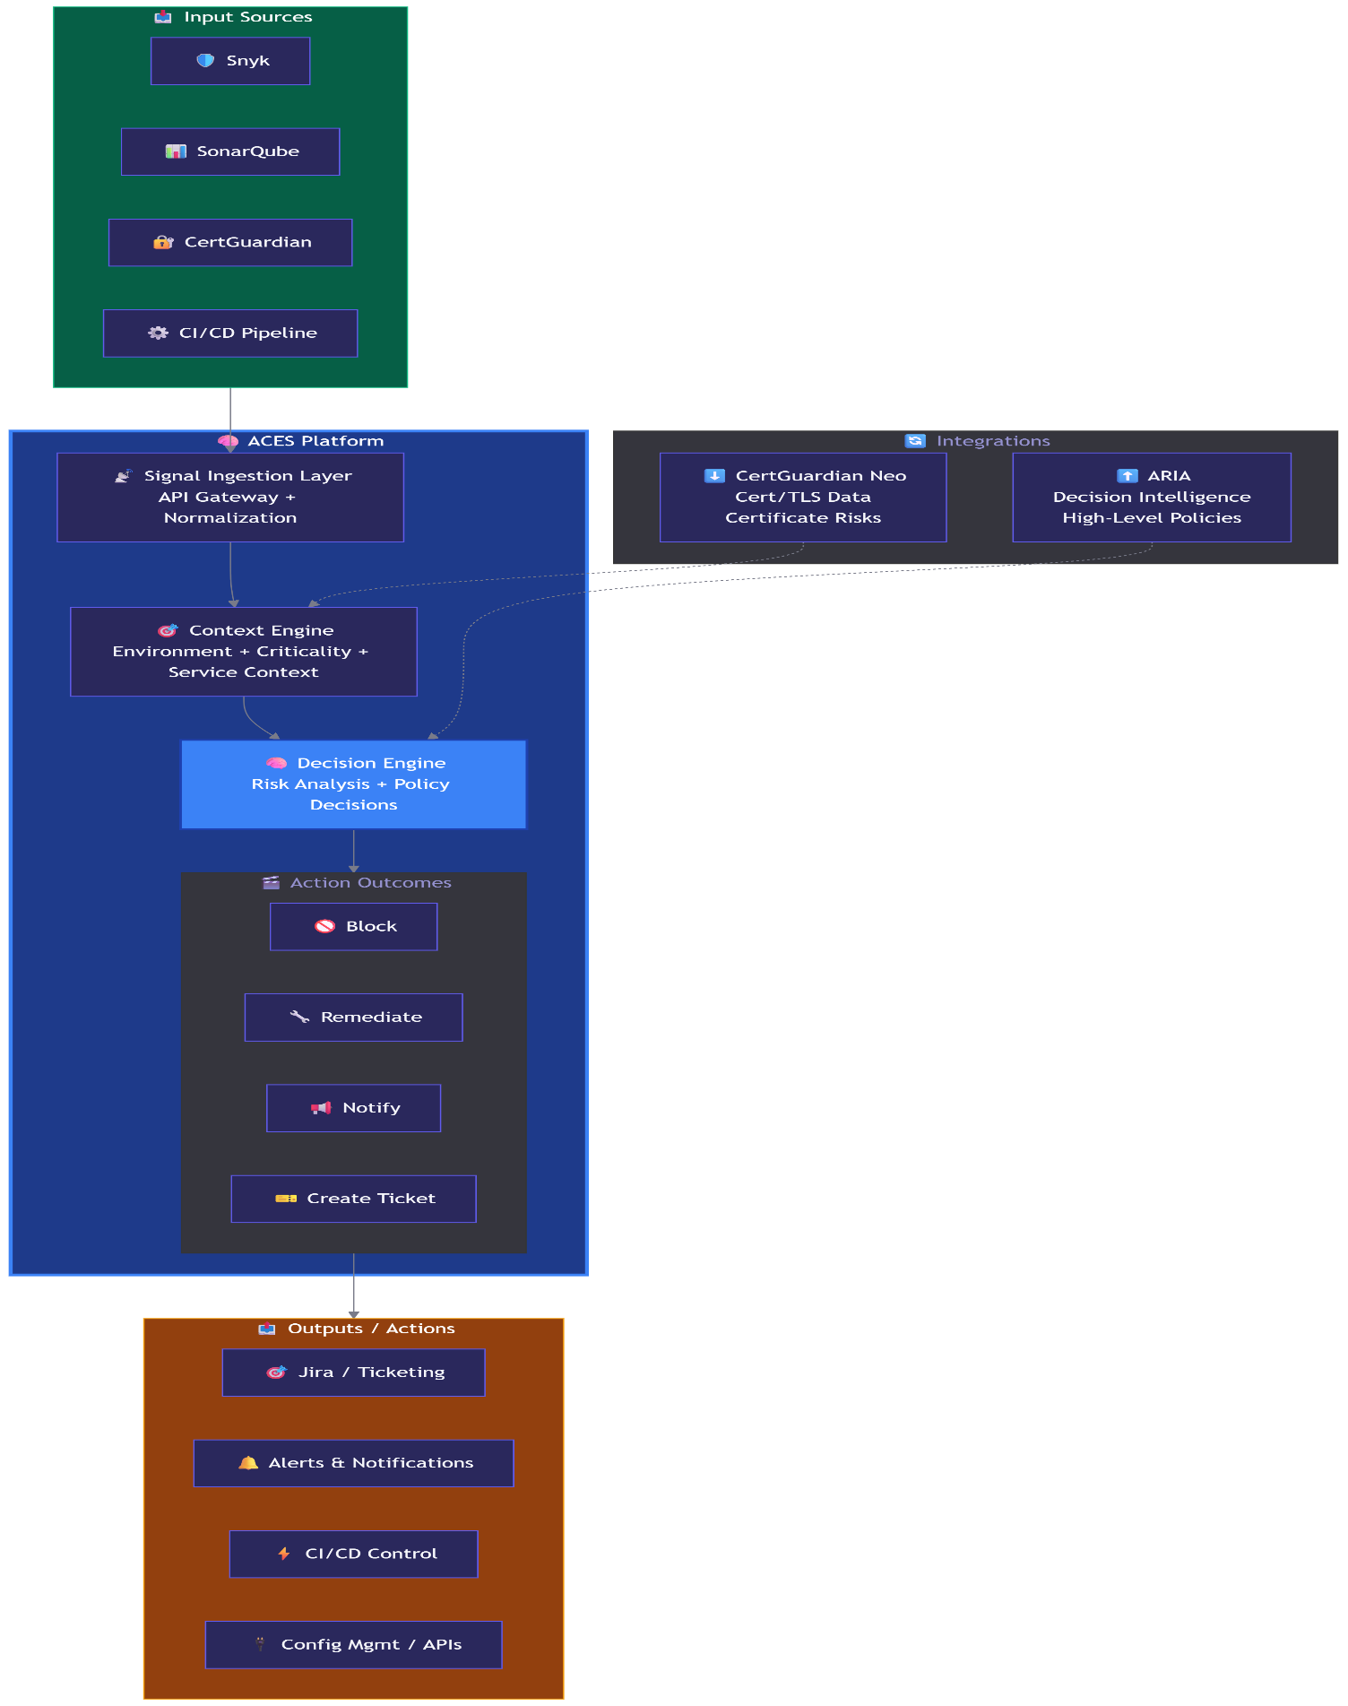

Diagram 2: End-to-End Flow (CertGuardian Use Case)
sequenceDiagram
participant CG as CertGuardian
participant ING as Ingestion Service
participant EVAL as Evaluation Service
participant DEC as Decision Engine
participant POL as Policy Service
participant ORCH as Orchestrator
participant AGENT as Agent/Plugin
participant VERIFY as Verification

CG->>ING: Signal: cert_runtime_mismatch
ING->>ING: Validate + Correlation ID
ING->>EVAL: Forward normalized event

EVAL->>EVAL: Compare observed vs expected
EVAL->>EVAL: Detect DRIFT ✅
EVAL->>DEC: Evaluation result

DEC->>DEC: Determine action needed
DEC->>DEC: Strategy: RESTART
DEC->>DEC: Skill: fix-cert-drift
DEC->>POL: Policy check

POL->>POL: Validate ownership
POL->>POL: Check environment
POL->>DEC: APPROVED ✅

DEC->>ORCH: Execute workflow
ORCH->>ORCH: Load skill definition
ORCH->>AGENT: Trigger restart

AGENT->>AGENT: Restart service
AGENT->>ORCH: SUCCESS

ORCH->>VERIFY: Verify outcome
VERIFY->>CG: Re-check certificate
CG->>VERIFY: New cert confirmed ✅
VERIFY->>ORCH: RESOLVED

ORCH->>AUDIT: Log complete trail
Note over AUDIT: Full audit trail<br/>Decision + Action + Outcome

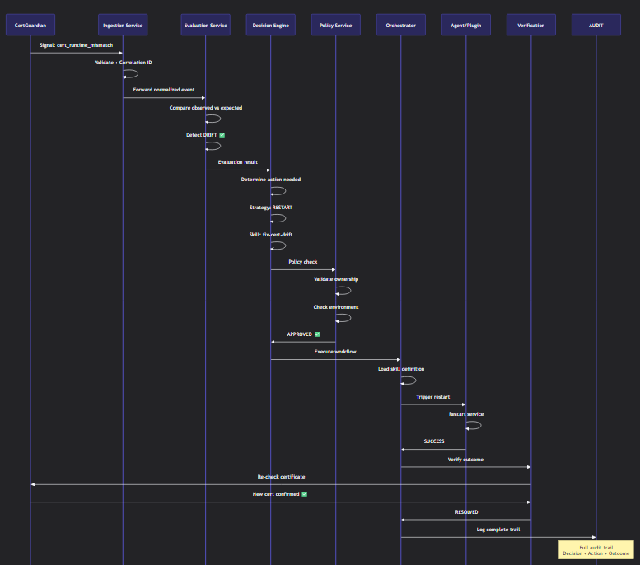

Diagram 3: Component Architecture
graph TB
subgraph Core["🎯 ACES Core Services"]
ING["📥 Ingestion Service<br/>- REST APIs<br/>- Event normalization<br/>- Correlation ID"]
EVAL["🔍 Evaluation Service<br/>- State comparison<br/>- Drift detection<br/>- Threshold checks"]
DEC["🧠 Decision Engine<br/>- Rule evaluation<br/>- Strategy selection<br/>- Risk scoring"]
ORCH["⚙️ Orchestrator<br/>- Workflow execution<br/>- Step management<br/>- Retry logic"]
end

subgraph Support["🛠️ Support Services"]
POL["📋 Policy Service<br/>- Access control<br/>- Approval gates<br/>- Constraints"]
AUDIT["📝 Audit Service<br/>- Decision logs<br/>- Action trail<br/>- Compliance"]
VERIFY["✅ Verification<br/>- Outcome validation<br/>- State re-check"]
end

subgraph Execution["🚀 Execution Layer"]
PLUGIN["🔌 Plugin Service<br/>- MCP adapters<br/>- Tool execution<br/>- API calls"]
AGENT["🤖 Agents<br/>- Restart service<br/>- Config update<br/>- Deploy"]
CICD["⚡ CI/CD<br/>- Pipeline trigger<br/>- Build control"]
end

subgraph Data["💾 Data Layer"]
DB["🗄️ PostgreSQL<br/>- Workflow state<br/>- Audit logs<br/>- Policies"]
CACHE["⚡ Redis<br/>- Session cache<br/>- Rate limiting"]
end

Core --> Support
ORCH --> Execution
Core --> Data
Support --> Data

style Core fill:#1e3a8a,color:#fff,stroke:#3b82f6,stroke-width:2px
style Support fill:#065f46,color:#fff,stroke:#10b981,stroke-width:2px
style Execution fill:#92400e,color:#fff,stroke:#f59e0b,stroke-width:2px
style Data fill:#581c87,color:#fff,stroke:#a855f7,stroke-width:2px
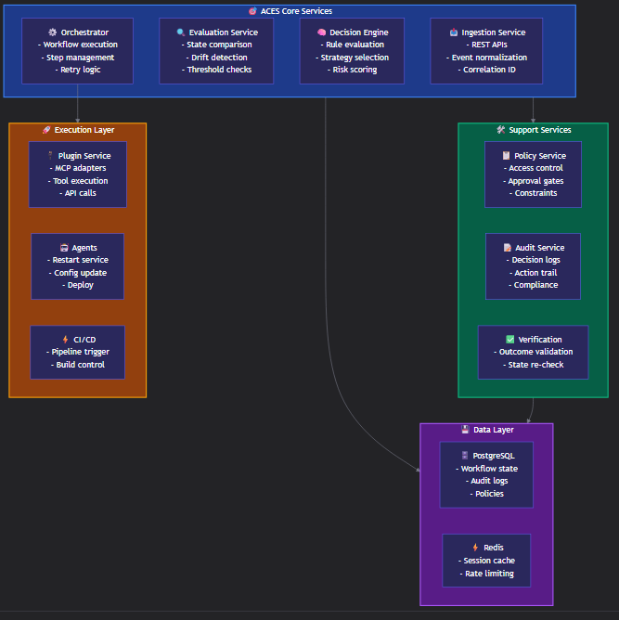

PART 3: EXACT API CONTRACTS
API 1: Signal Ingestion
Yaml
POST /api/v1/signals
Content-Type: application/json

Request:
{
"type": "cert_runtime_mismatch",
"source": "CertGuardian",
"seal": "payments",
"application": "payments-api",
"component": "gateway",
"payload": {
"expected_thumbprint": "ABC123...",
"observed_thumbprint": "XYZ789...",
"endpoint": "https://payments-api.jpmc.com/health"
},
"timestamp": "2026-05-01T10:30:00Z"
}

Response:
{
"status": "accepted",
"correlation_id": "aces-2026-05-01-abc123",
"evaluation_status": "pending",
"estimated_processing_time_ms": 500
}

API 2: Decision Query
Yaml
GET /api/v1/decisions/{correlation_id}

Response:
{
"correlation_id": "aces-2026-05-01-abc123",
"decision": {
"action_required": true,
"strategy": "RESTART",
"skill": "fix-cert-runtime-drift",
"confidence_score": 0.95,
"reasoning": "Certificate mismatch detected in production environment. Restart strategy selected based on 95% historical success rate."
},
"policy_check": {
"approved": true,
"approval_type": "auto",
"policy_id": "prod-cert-drift-auto-remediate"
},
"timestamp": "2026-05-01T10:30:01Z"
}

API 3: Workflow Execution
Yaml
POST /api/v1/workflows/execute
Content-Type: application/json

Request:
{
"correlation_id": "aces-2026-05-01-abc123",
"skill": "fix-cert-runtime-drift",
"inputs": {
"seal": "payments",
"application": "payments-api",
"component": "gateway",
"action": "restart"
}
}

Response:
{
"workflow_id": "wf-2026-05-01-xyz789",
"status": "in_progress",
"current_step": "validate_state",
"steps_completed": 0,
"steps_total": 4,
"started_at": "2026-05-01T10:30:02Z"
}

API 4: Verification

Yaml
POST /api/v1/verify/{workflow_id}

Response:
{
"workflow_id": "wf-2026-05-01-xyz789",
"verification": {
"status": "success",
"observed_state": {
"thumbprint": "ABC123...",
"matches_expected": true
},
"resolution_time_ms": 2340,
"retries": 0
},
"completed_at": "2026-05-01T10:30:05Z"
}

PART 4: WEEK 1 EXECUTION PLAN
Day 1 (Thursday): Foundation
Tasks:
- Create GitHub repo: aces-platform
- Setup Spring Boot 3 project structure
- Define common-models module
- Create base DTOs: Signal, EvaluationResult, Decision
- Setup PostgreSQL schema (basic tables)
Owner: You
Deliverable: Working project structure + models

Day 2 (Friday): Ingestion Service
Tasks:
- Create ingestion-service module
- Implement POST /api/v1/signals endpoint
- Add request validation (JSR-380)
- Generate correlation IDs
- Write unit tests (80% coverage)
Owner: Person 2
Deliverable: Working ingestion API

Day 3 (Saturday): Evaluation Logic
Tasks:
- Create evaluation-service module
- Implement drift detection logic
- Add threshold comparison
- Create EvaluationResult model
- Integration test: Signal → Evaluation
Owner: Person 2
Deliverable: Drift detection working

Day 4 (Sunday): Decision Engine (Basic)
Tasks:
- Create decision-engine module
- Implement rule-based decisions
- Create decision rules YAML config
- Add strategy selection logic
- Test: Evaluation → Decision
Owner: You
Deliverable: Decision engine MVP

Day 5 (Monday): Integration + Demo
Tasks:
- Wire all services together
- Create Postman collection
- End-to-end test: Signal → Decision
- Prepare demo script
- Team demo (15 mins)
Owner: All
Deliverable: Working end-to-end flow

WHAT TO SHARE AFTER THE MEETING
Create a GitHub repo with:

aces-platform/
├── README.md (with Mermaid diagrams embedded)
├── docs/
│ ├── architecture.md
│ ├── api-contracts.md
│ └── week-1-plan.md
├── diagrams/
│ ├── aces-overview.mmd
│ ├── certguardian-flow.mmd
│ └── components.mmd
└── api/
└── openapi-spec.yaml

FINAL TIPS FOR THE MEETING
- Draw the architecture live (even simple boxes) - helps people follow
- Repeat "Decision + Execution" multiple times - this is the core
- Show the CertGuardian example - concrete > abstract
- Emphasize Phase 1 scope - prevents over-engineering
- End with clear tasks - momentum is critical

You're ready. This package gives you everything:
- ✅ Clear script (speak naturally, don't read)
- ✅ Visual diagrams (render in Mermaid Live)
- ✅ Exact APIs (no ambiguity)
- ✅ Week 1 plan (actionable tasks)

